**How to connect sub module DS-K2M002X of DS-K270X controller with face terminal**

**Preparation**

|  |  |  |
| --- | --- | --- |
| Type | Model | Version |
| Software | IVMS-4200 or HCP or HCAC |  |
| Access Control Terminal | DS-K270X |  |
| Card reader | DS-K1T341CM |  |

**How to connect sub module DS-K2M002X of DS-K270X controller with face terminal**

**Introduction:** This article will introduce how to connect sub module DS-K2M002X of DS-K270X controller with face terminal.

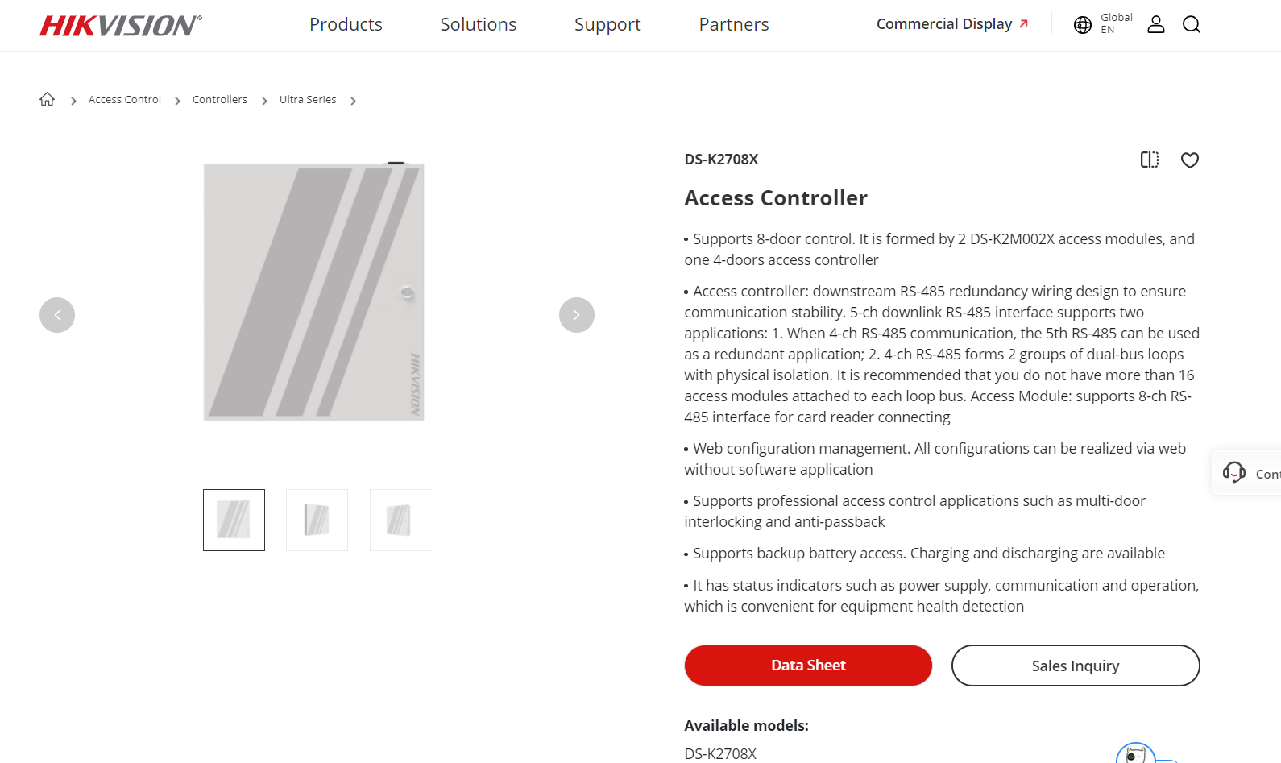

1. **Wiring**
2. Set the first access module 485 address is 1 corresponded dip switch 1000 0000, and 485A of access module connect to 485A of main controller.

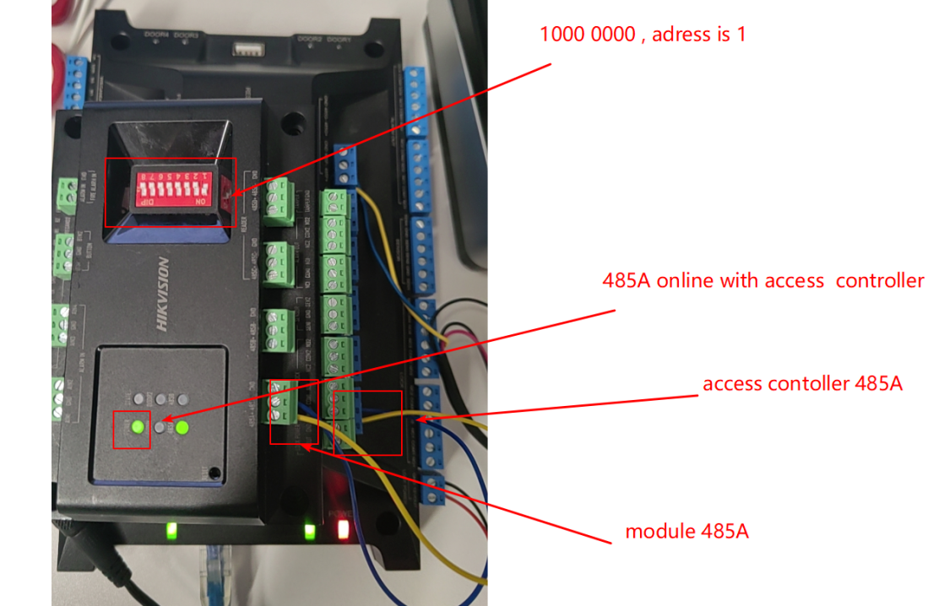

1. Face terminal connect to 485C of access module.

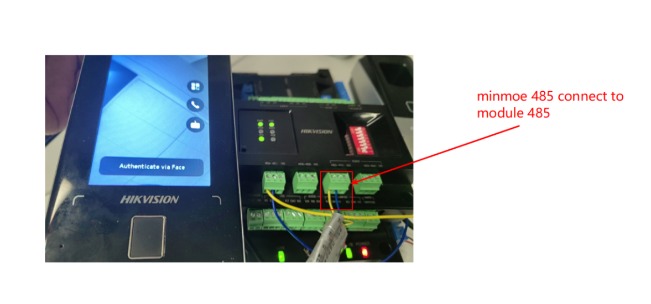

1. **Configuration**
2. Login the DS-K2704X web.

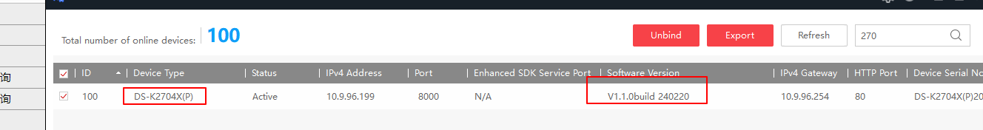

1. Add access module, make sure your module have connect to main access controller.

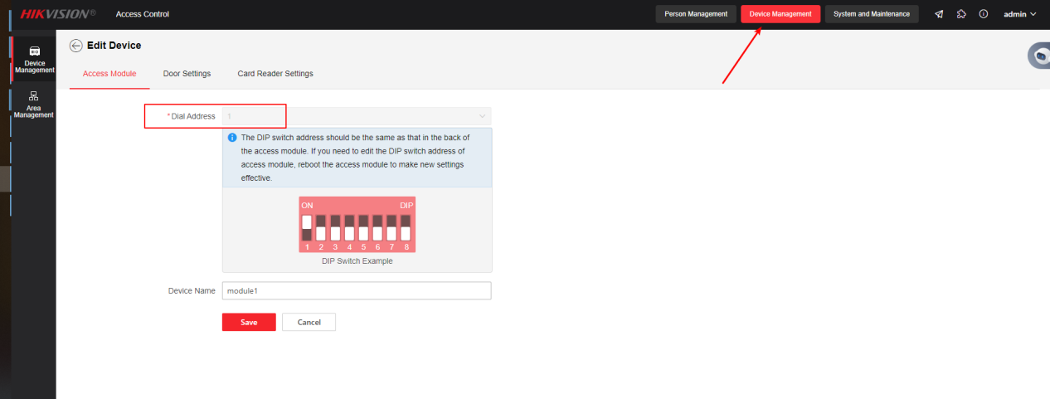

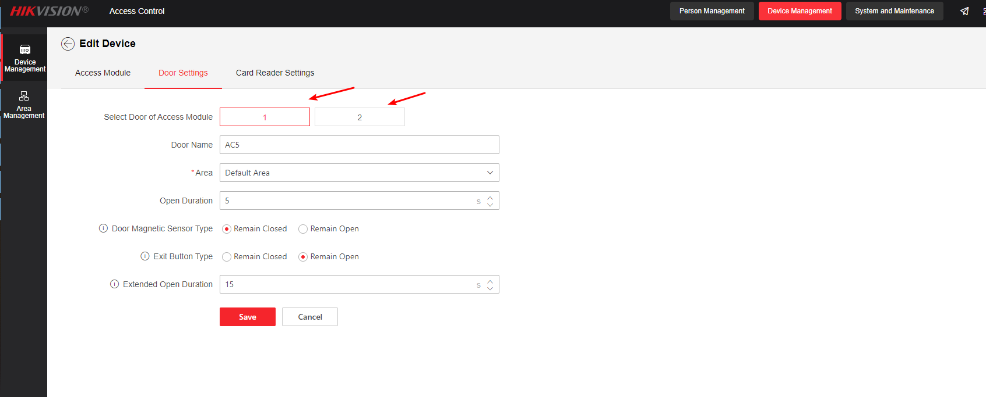

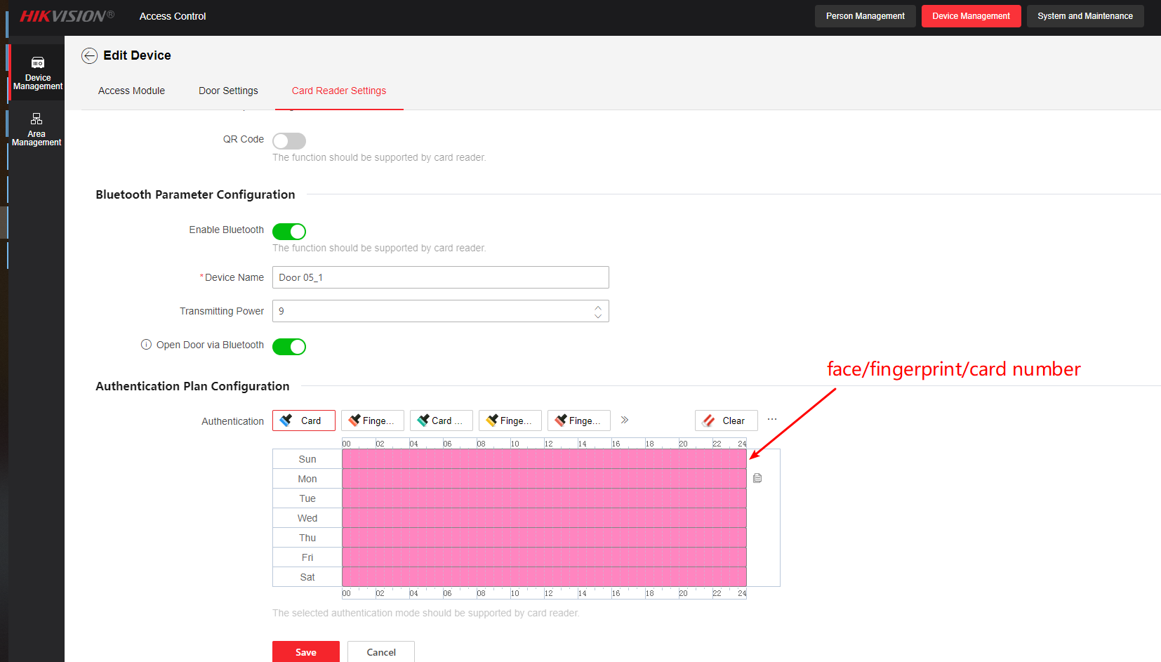

1. And then you can find your access module have been online

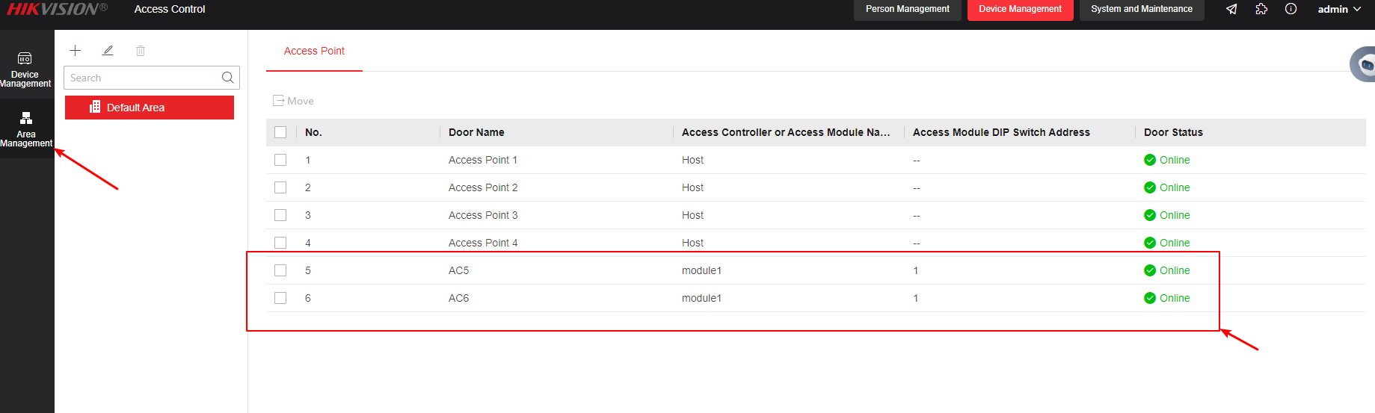

1. Login the face terminal web, if you want to control door 5, set 485 address is 1.

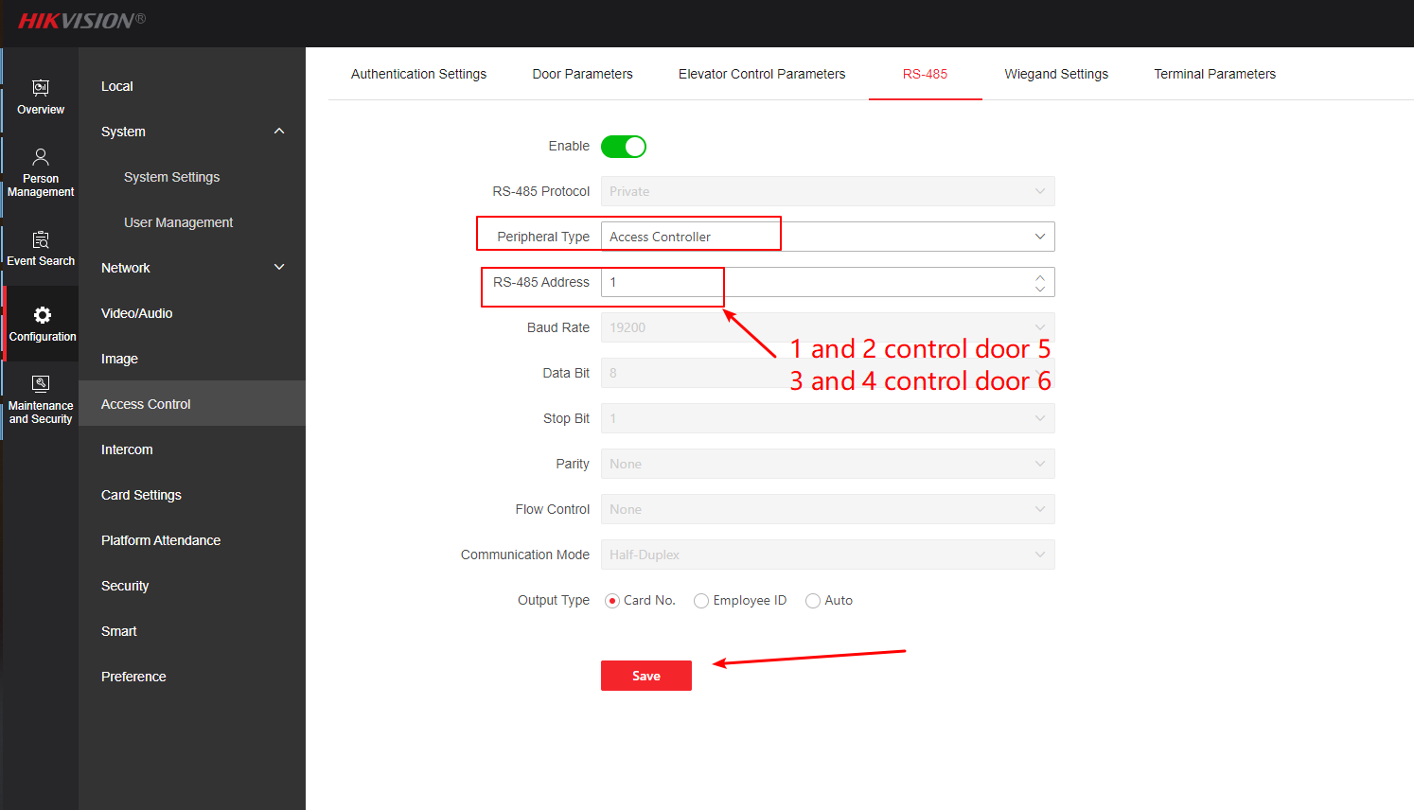

1. Check this card reader whether it is online, as shown below.

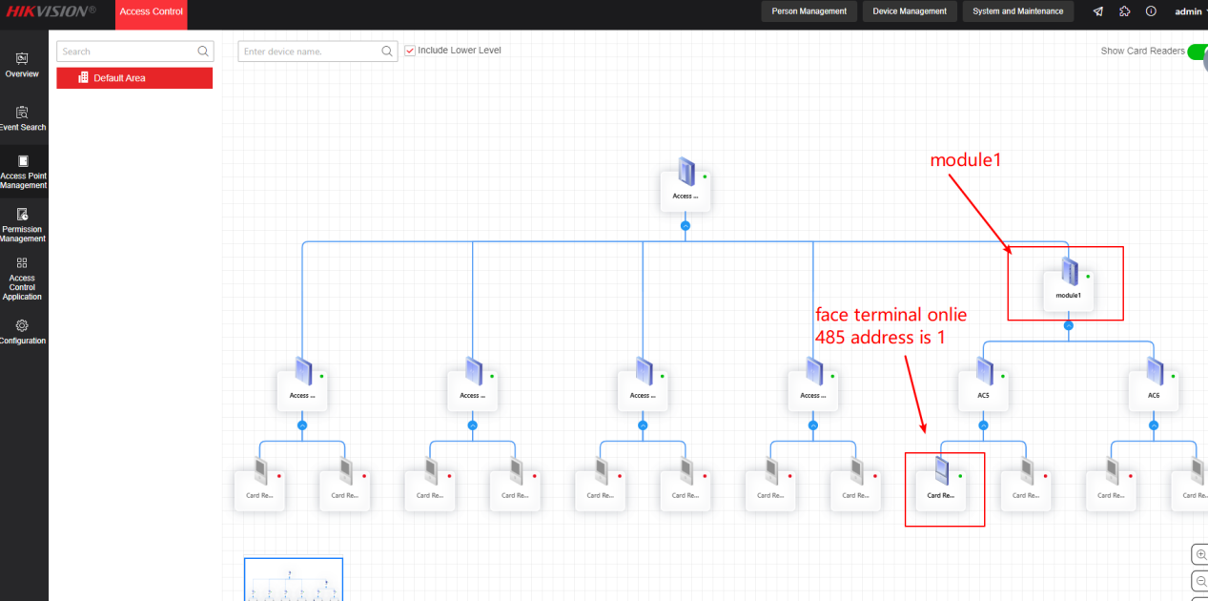

1. **Test**
2. Create a person on web of access controller and face terminal. You can also use IVMS-4200 to apply the access level.

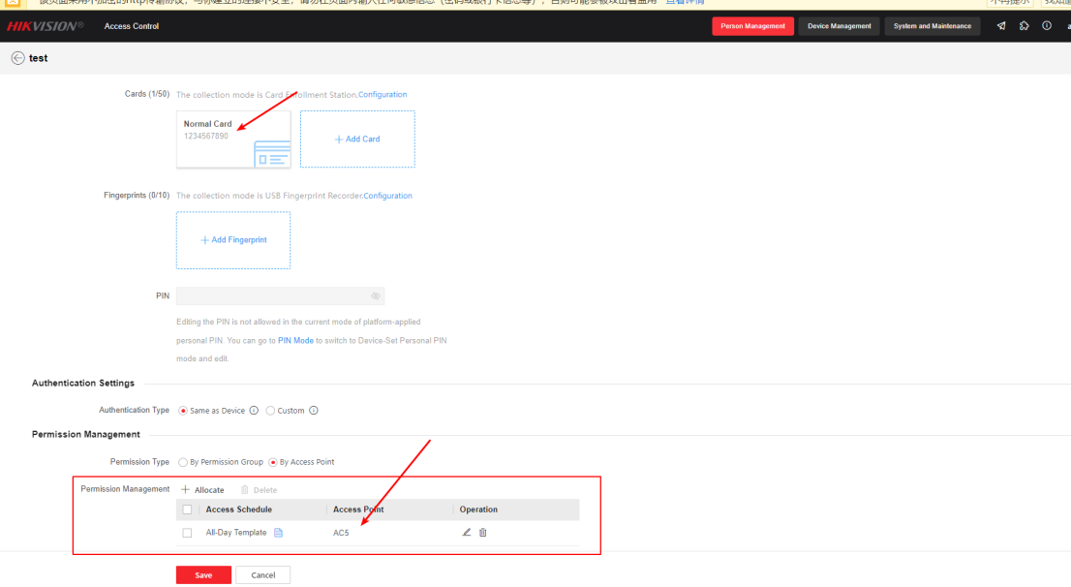

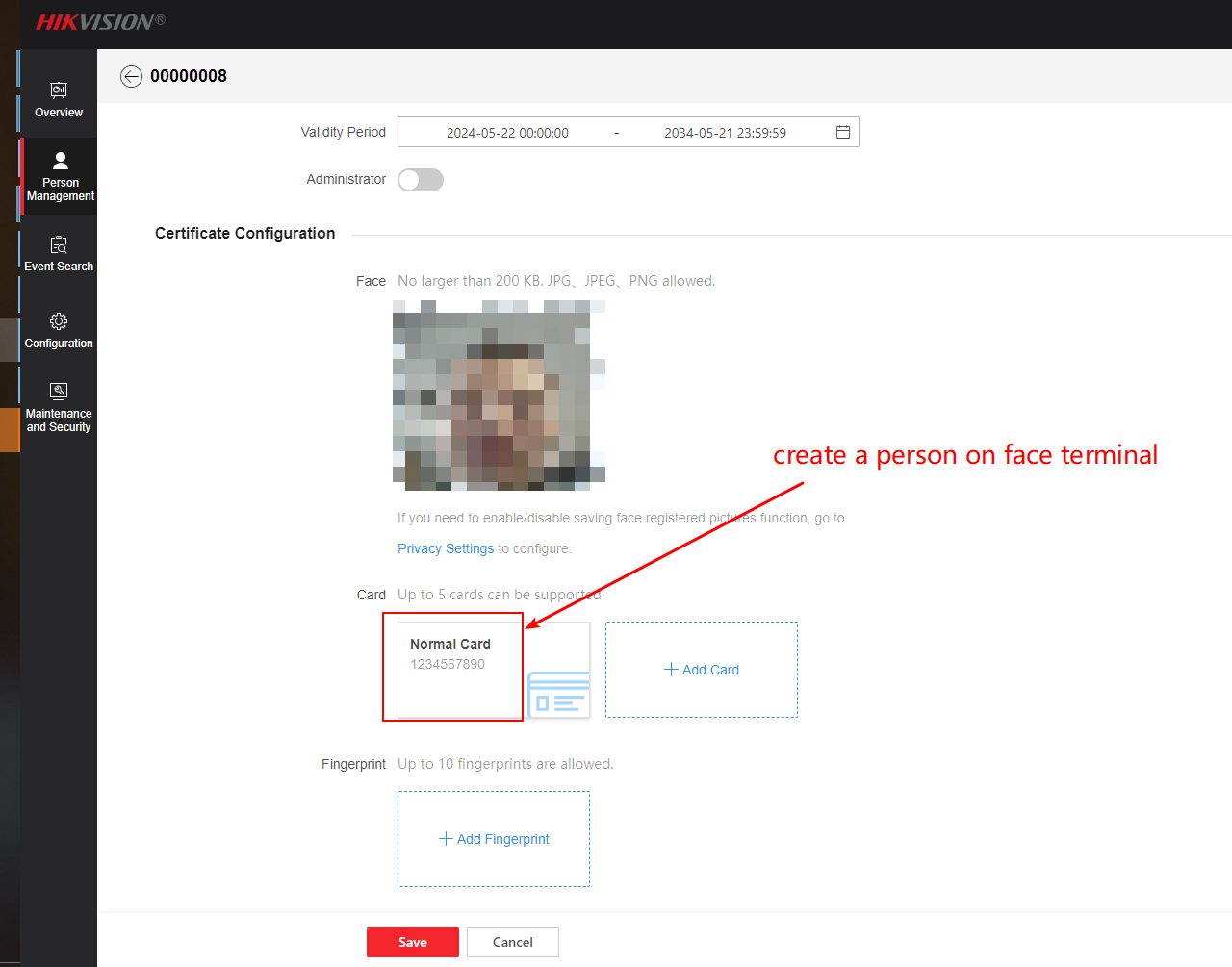

1. Swipe face to test, you can find the door5 is unlocked.

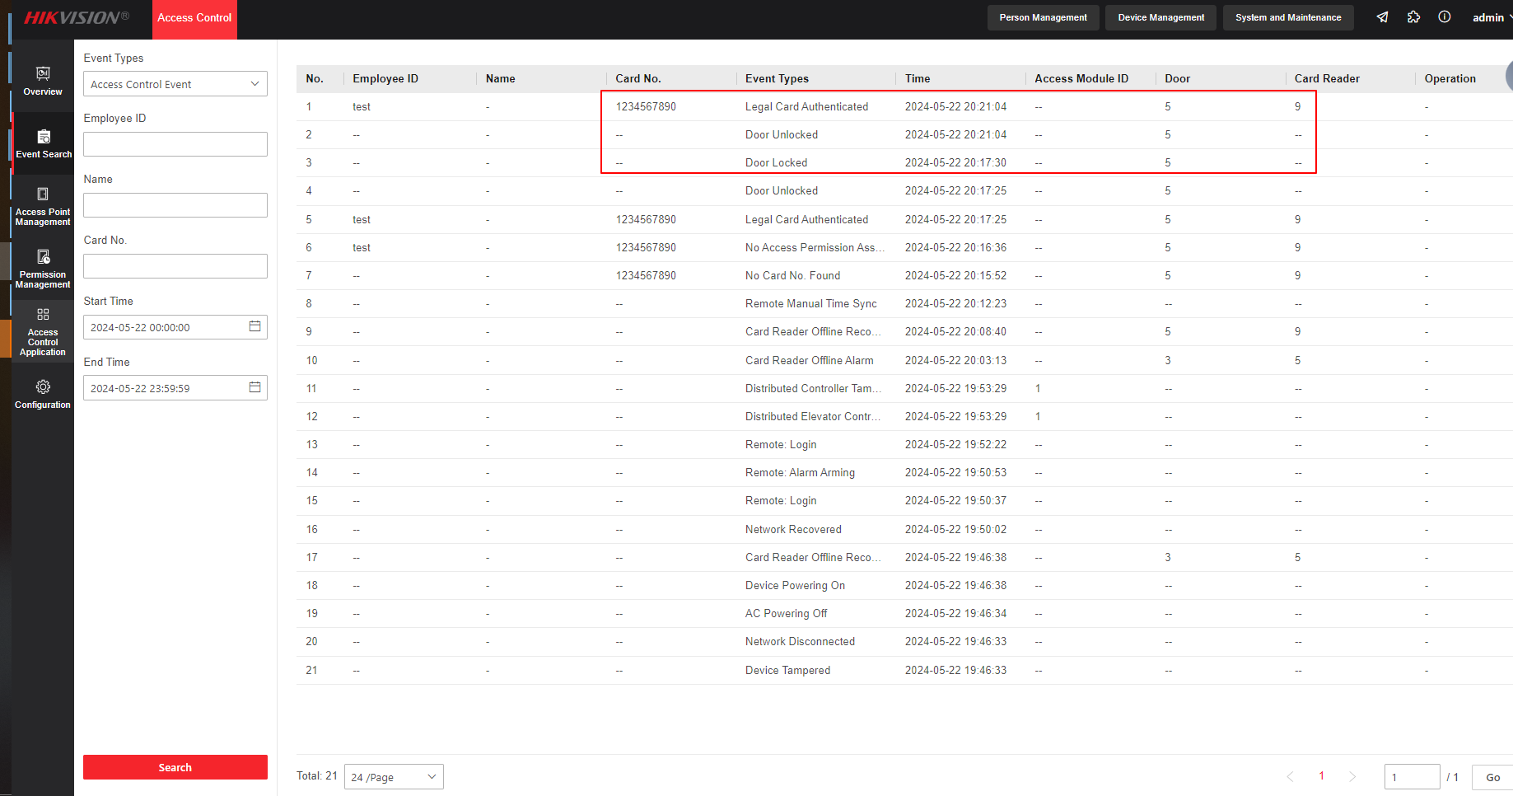

**Note:**

1. The access module can connect four card readers via 485 communication, address 1 and 2 open the door 1; address 3 and 4 open the door 2. The 485 address represented by the DIP switch of the card reader as show below. After the configuration is complete, the card reader needs to restarted.

1000 0000 - >1

0100 0000 - >2

1100 0000 - >3

0010 0000 - >4

1. About 485 Wiring of card reader, we recommend to use 485C interface, because it is the main communication of the card reader, and 485D is a redundancy interface.

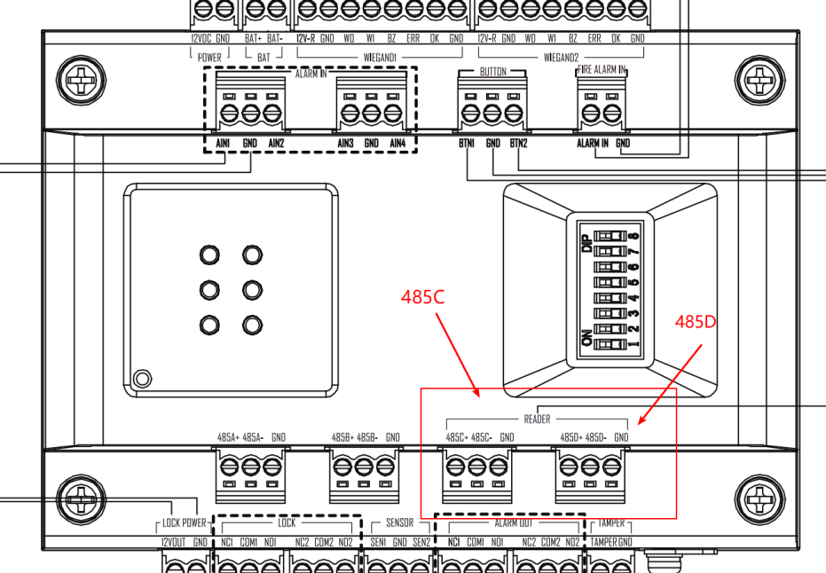

1. If you want to connect 485D interface of access module, you need check whether enable RS-485 communication backup.

